**KBC GAME REPORT**

**1. Introduction**

**“Kaun Banega Crorepati?”**

The “Kaun Banega Crorepati” game show was first introduced in October 2000. The show is currently on its fourth series.The game begins with 10 contestants who participate in the “fastest finger first” round competing to answer a question in the quickest. The winner then goes on to play for the Rs. 50,000,000 trying to answer 13 questions successfully, with each correct answer giving an increase in the amount of money won. To aid the contestant with the question answers, 4 help facilities are provided known as “life lines”. These “life lines” include; “phone a friend”, the contestant can phone a pre-selected friend to assist with the question answer, “ask the audience”, the studio audience help by voting for the correct answer, “fifty fifty” two wrong answers get exist; “flip a question” ;contestant can get another question in lieu of the present question if he is not able to answer the present question . When a contestant answers a question incorrectly they exit the game”.

**6.1.1 PURPOSE:**

This specification document describes the capabilities that will be provided by the web application “Kaun Banega Crorepati”. It also states the various required constraints by which the system will abide. The intended audience for this document is the development team, testing team and end users of the product.

**6.1.2 SCOPE:**

The web application (Game Show) “Kaun Banega Crorepati” which shows integration of login and information display modules into one application. In this application, if the user is valid then it enters successfully in order to play the game otherwise he can only watch the game proceedings. The central repository of all records helps Oraganizer (administrator) to add new questions ,delete previously asked questions easily and helps in reductions any anomalies and redundancy.

**4. Analysis:**

**4.1. User Requirements:**

User requirements are processes that the user of the application should be able to carry out. They are also contributing factors that are not related to application functionality like cost, time, safety and standards. User requirements can be split into two distinct subcategories these are functional and non-functional.

Functional requirements for the user should describe the services which the system should provide in a general way. They should be explained in a plain language so the user can understand them as well as the technical expert. They should include all the services the system needs to carry out for the user and this should be down in a consistent and non – ambiguous manner.

Non Functional requirements for the user are not directly concerned with the specific functions of the system. Below are the requirements which our group has defined for the “Who Wants to be a Millionaire system”.

**4.1.1. Functional Requirements:**

• The user should be able to log in to the system using a user name.

• The user should be able to answer the question .

• The user should be able to choose a life line to help them answer a question.

• If a user has already selected a life line they will be unable to select it again.

• The user should be able to quit the game at any time.

: Adding question

: Deletion of Record

: Exit from the game

: Create User Account

: AdminLogin

: Play Game

**4.1.2. Non – Functional Requirements**

• The user should be able to access the application via a PC.

• The system should have a GUI that is user friendly.

• The system will have no financial constraints.

**Reliability and Recovery:**

It is imperative that database should be always up when put into the product. During period of intense activities like submission and verification and updation of data, back up should be taken. It will help to minimize downtime in case of failure. Any abnormal operations shall result in the shutting down of the system.

But as our system is standalone and does not perform complicated tasks and not much hard to built again so its not imperative to take a backup for this small system.

**SOFTWARE AND HARDWARE REQUIREMENT**

**SPECIFICATIONS:**

**HARDWARE:**

The hardware details include the basic configuration of the computer system (i.e. all the devices are interconnected to form a system) as well as details about the network connection, if any. The system, on which this project has been designed, is a personal computer to the internet or the web, as it is better known. Following are the grass root details of the system configuration: -

**Personal Computer**

**Hardware**

We need at least a computer with the following specifications:-

RAM 1 GB or above

Hard disk 500 GB or above

CD-ROM Combo Drive

Color Monitor 14 inch or above

Keyboard Logitech

Mouse Scrolling Logitech

**SOFTWARE**

**During the development of the project, we need WINDOWS 10 with the following software utilities:**

* HTML, CSS and Basic JavaScript for the front end.
* PHP and MySQL for the back end.

**DESIGN**

**Data-Flow Diagrams (DFD)**

Data-flow diagrams is a graphical representation of the “Flow” of the data through an Information System and also used for the visualization of the data processing. In the late 1970s Data-flow diagrams (DFDs) were introduced and popularized for structured analysis and design (Gane and Sarson 1979).  DFDs show the flow of data from external entities into the system, showed how the data moved from one process to another, as well as its logical storage. Representantion of an example of a DFD is using the Gane and Sarson notation.  The Data flow Diagram shows the flow of data. It is generally made of symbols given below:

1. A square shows the Entity.
2. A Circle shows the Process
3. An open Ended Rectangle shows the data store.
4. An arrow shows the data flow.
5. The DFD can be up to several levels. The 0 level DFD states the flow of data in the system as seen from the outward in each module.
6. The first level DFD show more detail, about the single process of the 0 level DFD
7. The second level DFD can show even more details and so on.

Admin

Employee Report

Logs-in/ update database

Logs-in/

plays quiz

Quiz Result

**Level 0 DFD**

**Level 1 DFD**

Administrator

Manage Users

User id and Password

Questions

Update Record

User id and Password

Question Generated

Employee

Plays Quiz

Question Selection

Quiz Result

**1.Login**

Validation

User

Accountant

User id and Password

Authentication

User id and Password

Authentication

User Account

Checking id and password

**Level 2 Data Flow Diagram**

**9.ENTITY RELATIONSHIP DIAGRAM:**

Definition: An entity-relationship (ER) diagram is a specialized graphic that illustrates the interrelationships between entities in a database. ER diagrams often use symbols to represent three different types of information. Boxes are commonly used to represent entities. Diamonds are normally used to represent relationships and ovals are used to represent attributes.

Also Known As: ER Diagram, E-R Diagram, entity-relationship model

Examples: Consider the example of a our project “Kaun Banega Crorepati” and its database. The ER diagram shown in the image below contains two entities -- user and Game. There is a single "Plays" relationship. In our example there are many attributes associated with each entity. User have , user_name, passoword, email and game have game_id and category. In a real-world example, each one of these would likely have many different attributes.

ER-Diagram :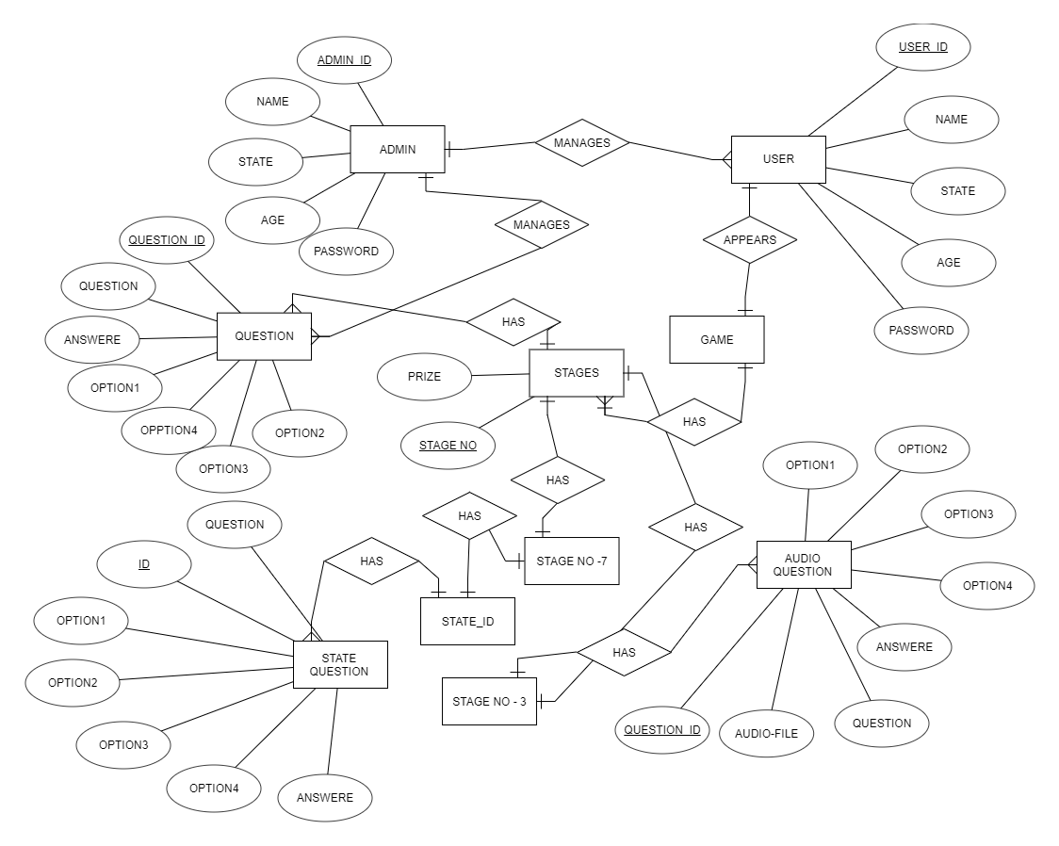

**10. Use Case Diagram :**

Use Cases, also called ‘user scenarios’, can provide a useful way of documenting:

• What the user will do with the planned software application.

• How the application will respond.

In UML, use cases are represented with a Use Case diagram. Within the diagram, a Use Case is represented by an ellipse with the name of the use case below this. A number of Use Cases are connected with various user/actors in the diagram with an interaction arrow. These diagrams are developed using an application called Rational Rose

Enterprise Edition.

The Use Case diagram, as shown represents what actions are taken by the user within the working system.

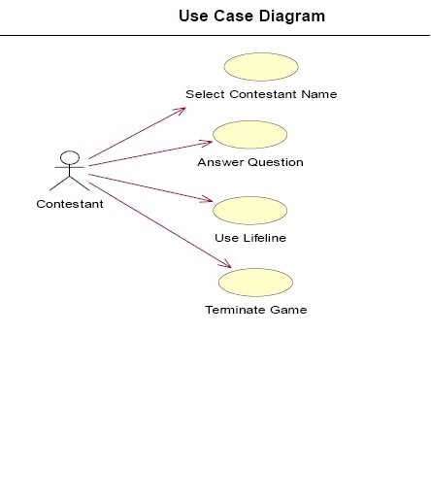

**Kaun Banega Crorepati Use Case**

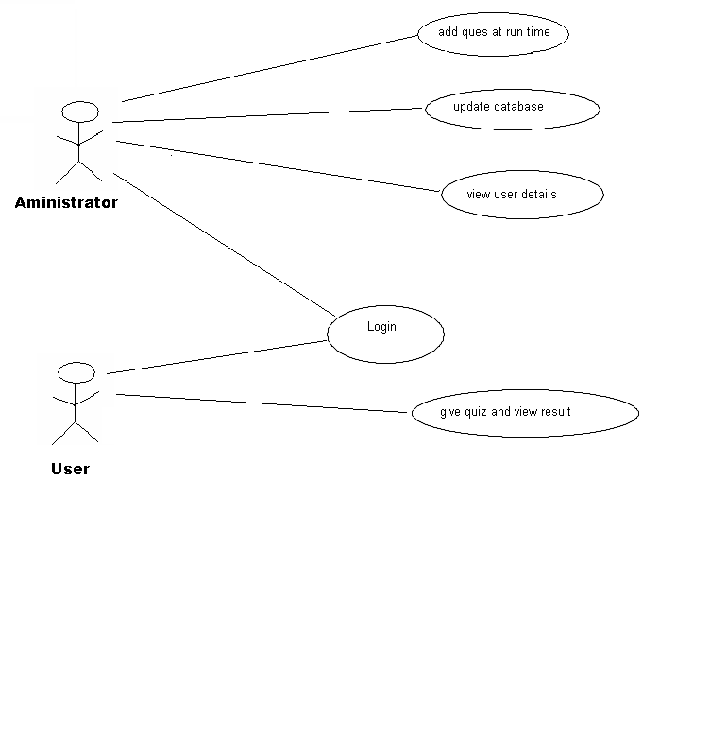

**11. Sequence Diagrams :**

Sequence diagrams can be drawn at different levels of detail and also to meet different purposes at several stages in the development life cycle. Sequence diagrams show the sequence of interactions between objects that are arranged in a time sequence, and an actor usually initiates these interactions.

The select contestant sequence diagram, as shown in the figure below represents what actions are taken by the user to select a contestant within the application.

The answer question sequence diagram represents what actions are taken by the user when answering a question.

The select life line sequence diagram represents what actions are taken by the user uses a lifeline within the application.

The terminate game sequence diagram, represents what actions are taken by the user when they terminate the game.

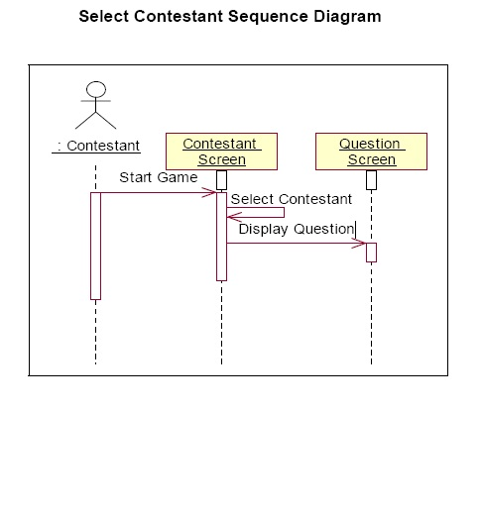

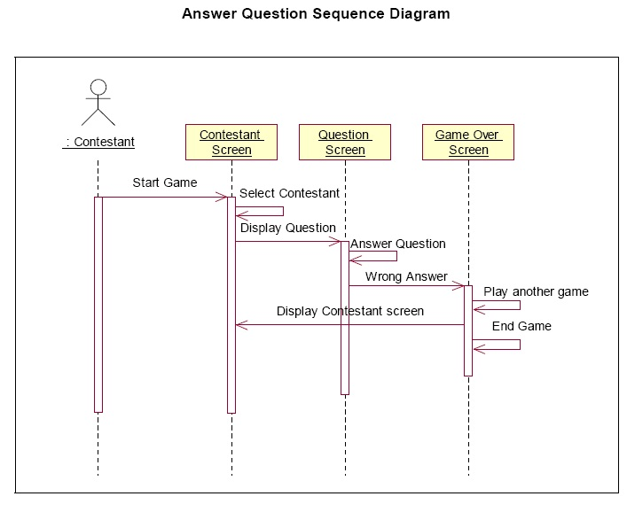

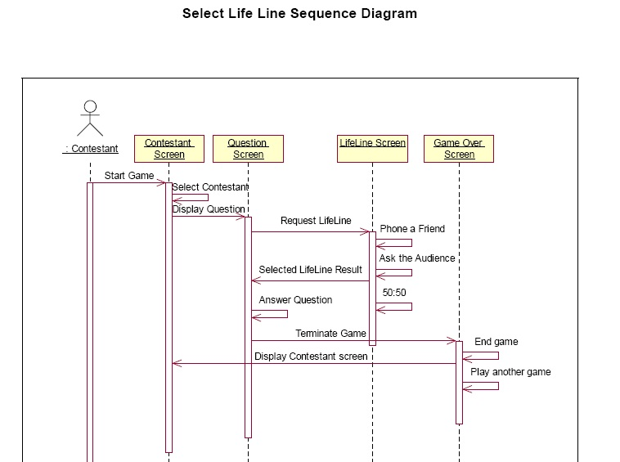

**Terminate Game Sequence Diagram**

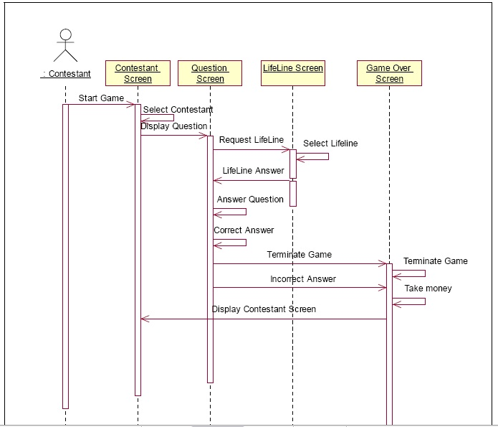

**:: Testing :**

**12.2. Testing Documentation :**

Testing has a dual function within a system. It is used to ascertain the presence of defects in a system and it is used to help judge whether or not the system is usable. The testing process can demonstrate the presence of errors but can not show that there are no errors within the system. Within this different testing techniques will be discussed and the preferred testing method for the Kaun Banega Crorepati will be detailed.

**Black Box**

Black box testing is defined by Sommerville as “testing which relies on the specification of the system or component which is being tested to derive test cases” (Sommerville, 2001, p.466). The system is a ‘black box’ in that the internal workings of the item being

tested are not known to the tester. The tester will only know the inputs to the system and the expected outcomes, but will not know how the system arrives at those outcomes.

**White Box testing**

White box testing is a method which requires the tester to have explicit knowledge of the internal workings of a system. Sommerville cites that “the tester can analyse the code and use knowledge about the structure of a component to derive test data”.

(Sommerville, 2001, p.471). In this case the tests are only accurate if the tester knows what the program is supposed to do.

**Unit Testing**

Testing of the Kaun Banega Crorepati game was carried out following the Unit Testing methodology. Each individual function of the system was thoroughly tested and evaluated to ensure that the working system meets user requirements. Sommerville (2001, p.449) states that “individual components are tested to ensure that they operate correctly. Each component is tested independently, without other system components.”

**Test Plans**

The test scripts for the Kaun Banega Crorepati game are written to satisfy the unit testing method. The aim of these scripts is to find out if the system meets its specification which is outlined in the specification. This section will discuss the test plans that have been created, the expected result from the test plans and the actual result achieved.

Load Game:

|  |  |  |  |  |  |  |
| --- | --- | --- | --- | --- | --- | --- |
| **Ref.** | **Purpose** | **Test Data** | **Expected**  **Result** | **Actual**  **Result** | **Date** | **Comment** |
| 1. | Test  if the game  loads  efficiently | Load VB 6.0 and open GAme | System  loads  game | As  Expected | 8/12/2010 |  |

Login Screen:

|  |  |  |  |  |  |  |
| --- | --- | --- | --- | --- | --- | --- |
| Ref. | Purpose | Test Data | Expected Result | Actual Result | Date | Comment |
| 1. | Test  Username  Login | Click on  relevant  username  button | System  prompts a  Welcome  message | As  Expected | 8/12/2010 |  |

Question Screen:

|  |  |  |  |  |  |  |
| --- | --- | --- | --- | --- | --- | --- |
| Ref. | Purpose | Test Data | Expected Result | Actual Result | Date | Comment |
| 1. | Test  Questions | Answer  relevant  question  displayed  stating A ,  B,C or D. | System  displays  Total  Winnings  Screen | As Expected | 8/12/2010 |  |
| 2. | Test  Questions | Answer  question  displayed  stating the  actual  answer  displayed | System  displays  Running  Totals  Screen | As Expected | 8/12/2010 |  |
| 3. | Answer  question  incorrectly | System  displays  Total  Winnings  Amount | System  displays  Total  Winnings  Amount | As Expected | 8/12/2010 |  |
| 4. | Test  Questions | Choose  lifeline | Displays life  line screen | As Expected | 8/12/2010 |  |

LifeLine Screen:

|  |  |  |  |  |  |  |
| --- | --- | --- | --- | --- | --- | --- |
| **Ref.** | **Purpose** | **Test Data** | **Expected**  **Result** | **Actual**  **Result** | **Date** | Comment |
| 1. | Test  Life line  options | Choose  phone  friend life  line | Message Box  appears  with a  Phone A Friend  dialogue. | As Expected | 8/12/2010 |  |
| 2. | Test  Life line  options | Choose  50:50  option | Displays  the  question  with two  options  removed  from the  answer | As Expected | 8/12/2010 |  |
| 3. | Test  Life line  options | Choose  Ask the  Audience  option | Displays  the Table  showing  results from  audience. | As Expected | 8/12/2010 |  |

Running Total And Total Winning:

|  |  |  |  |  |  |  |
| --- | --- | --- | --- | --- | --- | --- |
| Ref. | Purpose | Test Data | Expected Result | Actual Result | Date | Comment |
| 1. | Test if  winnings  MsgBox  displays  correctly | Answer a  question  correctly | System  displays  updated  total of  cash won in  the running  Label | As Expected | 8/12/2010 |  |
| 2. | Test if  winnings  MsgBox  displays  correctly | Answer a  question  incorrectly | System  displays  amount of  cash won in  total  winnings  Label | As Expected | 8/12/2010 |  |
| 3. | Test if  winnings  MsgBox  displays  correctly | Answer a  question  incorrectly | System  displays a  “Game Over”  Label | As Expected | 8/12/2010 |  |

**SCREENSHOTS**

**User Interfaces:**

1.Login interface:

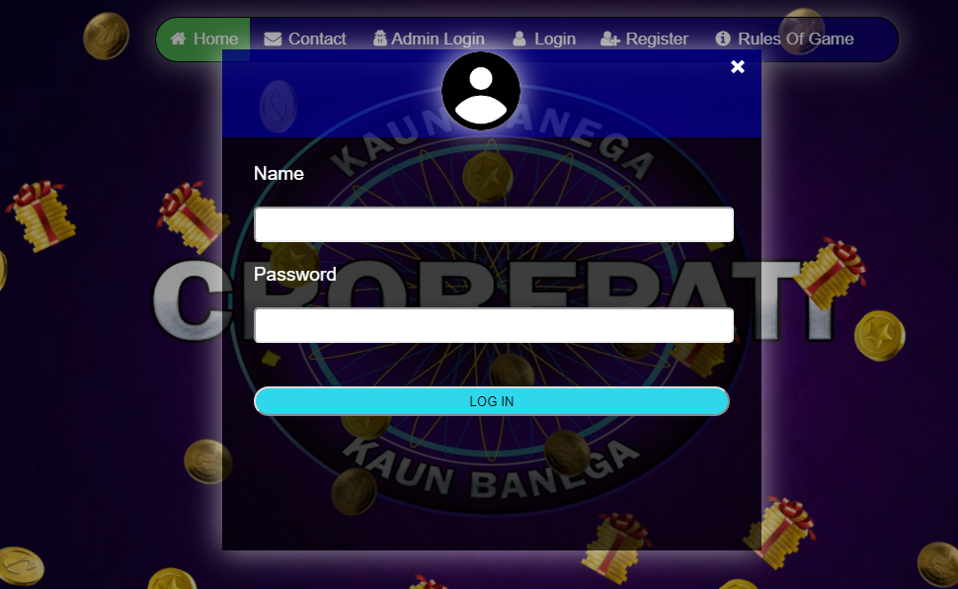

2. Home page:



3.Add new user :

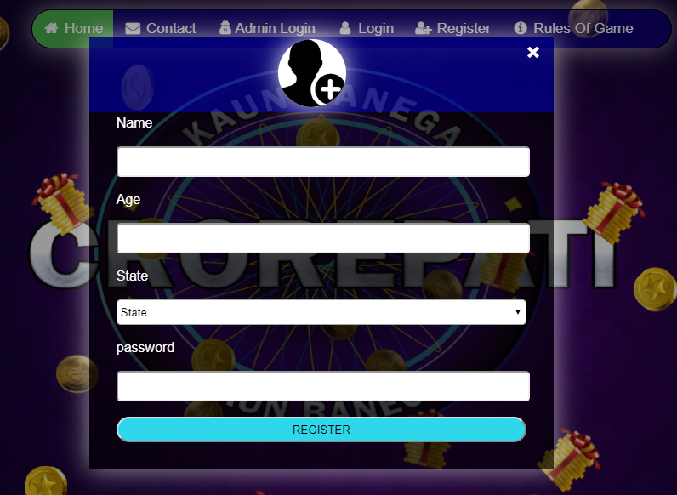

4.Admin Home page:

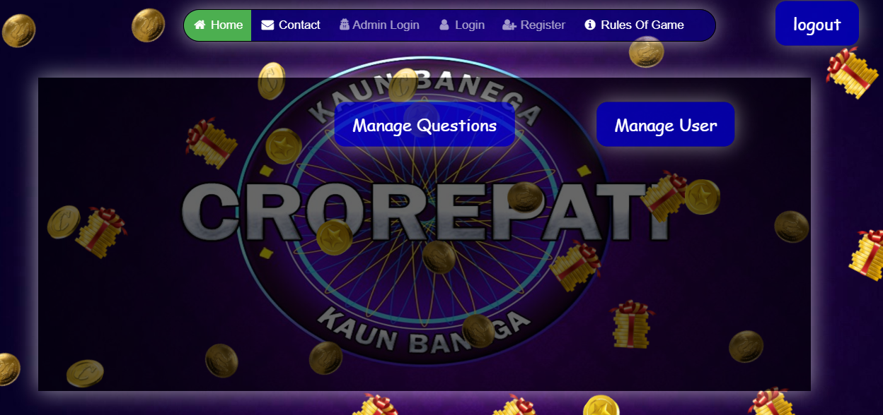

5.Manage Question(admin):

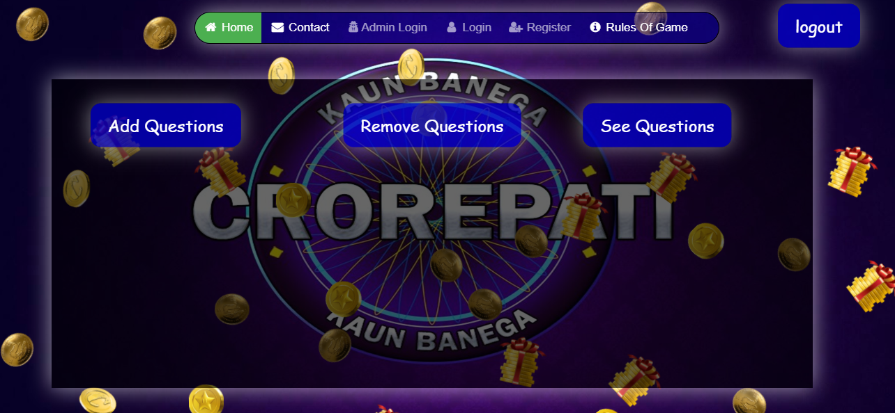

6.Add Question(admin):

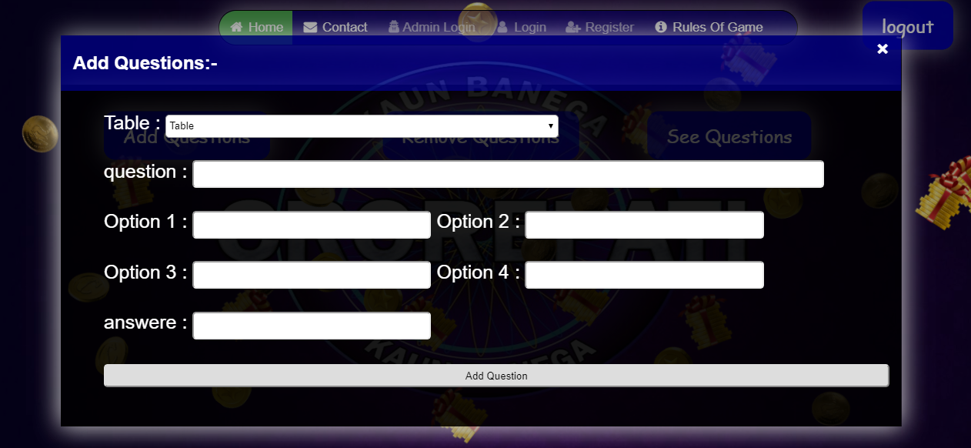

7.Remove Question(admin):

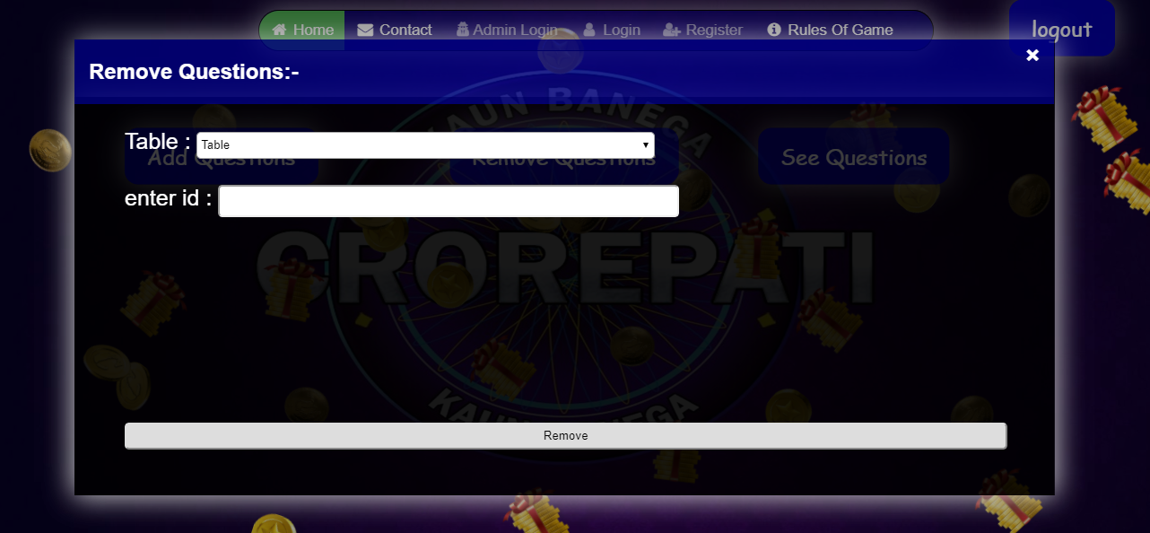

8.See Question(admin):

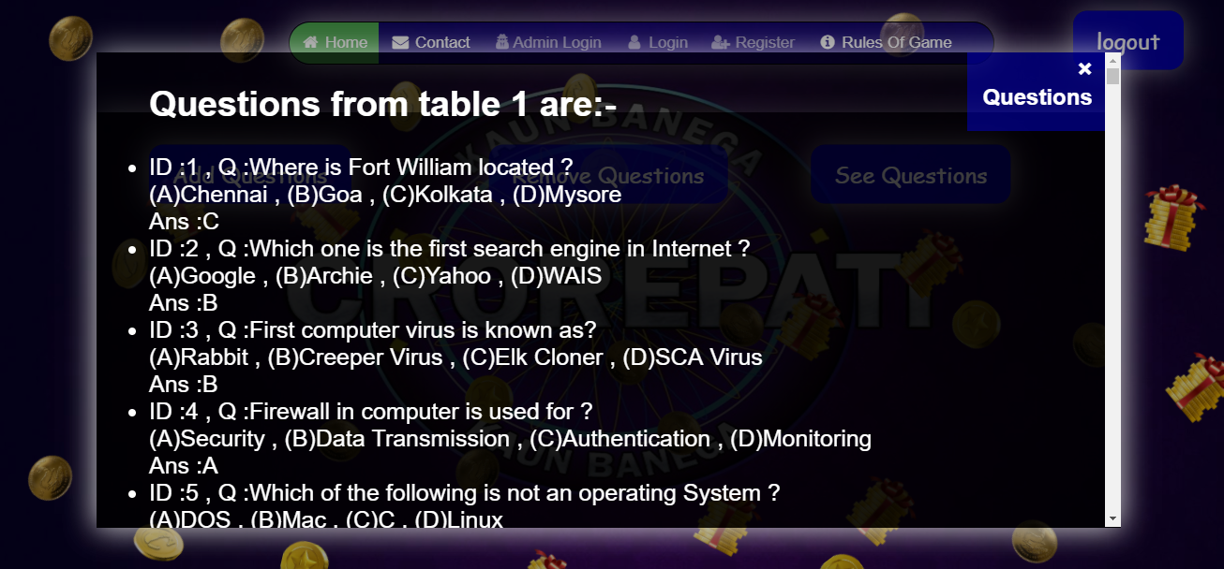

9.Manage Users(admin):

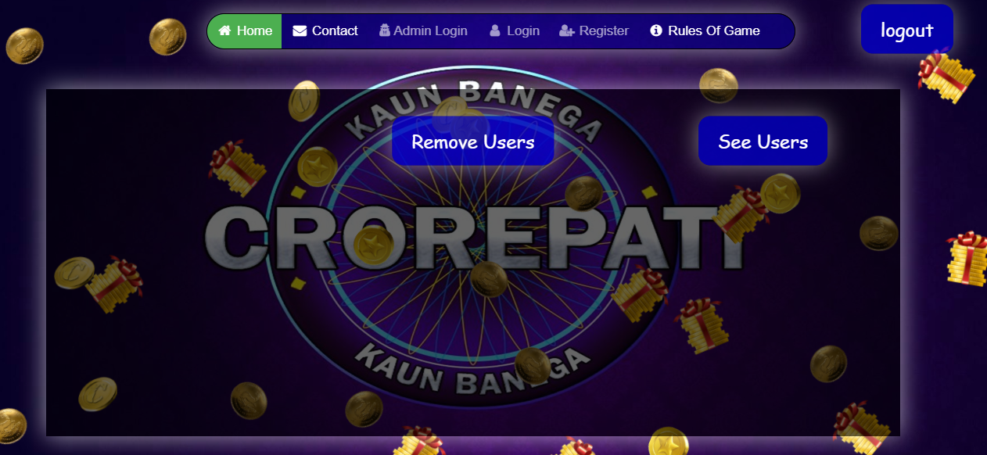

10.See Users(admin):

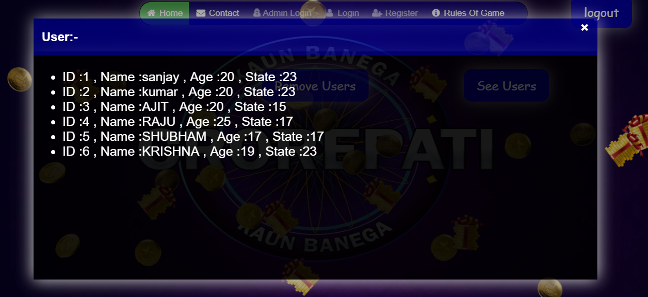

11.User home page:

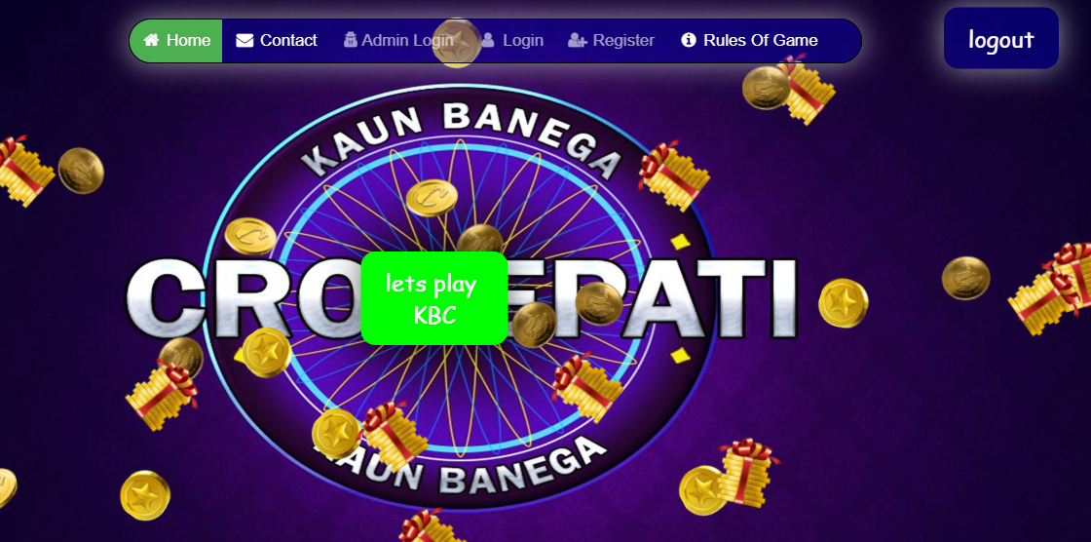

12.Quiz questions :

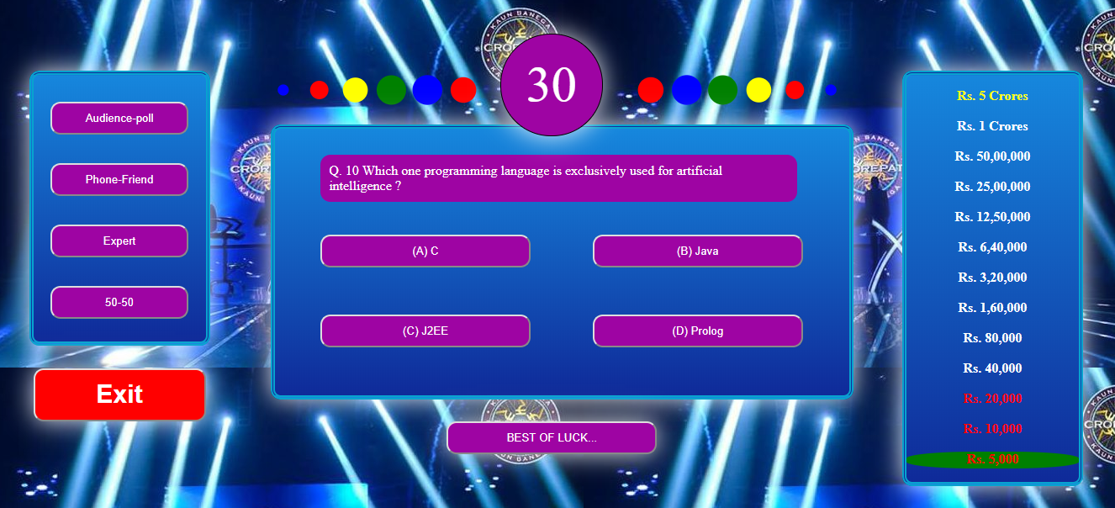

13.Lifeline :

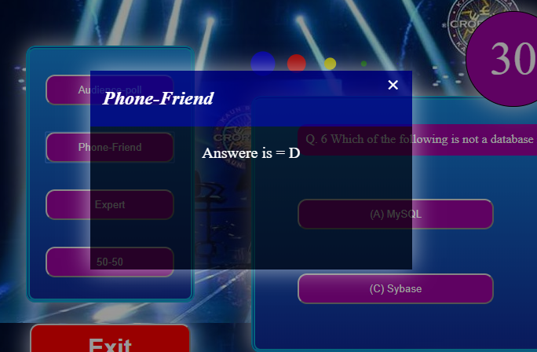

14.Lifeline(used) :

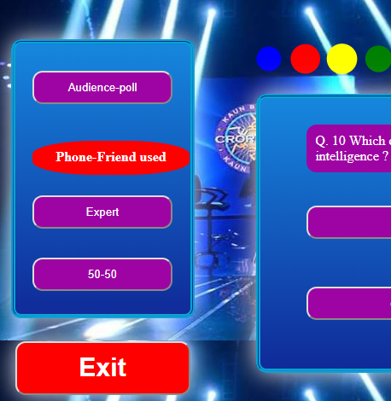

15.prize:

